Ideation Phase
Empathize & Discover

Date | 02 july 2026
Team ID
Project Name | Sports Hall Booking System using Service Portal (ServiceNow)
Maximum Marks | 4 Marks

Empathy Map Canvas:
An empathy map is a simple and effective visual tool that helps understand the needs, behaviours, expectations, and challenges of users involved in the Sports Hall Booking System. It provides insights into how students, faculty, and sports hall managers interact with the booking process and identifies areas where the system can improve their overall experience.
It helps the project team better understand the users by capturing what they think, feel, see, say, hear, and do while booking or managing sports hall reservations.
Creating an effective Sports Hall Booking System requires understanding the real problems faced by users, such as difficulty checking hall availability, manual booking processes, booking conflicts, delayed approvals, and lack of booking status updates. Developing the empathy map encourages the team to view the booking process from the users' perspective, helping design a user-friendly, efficient, and automated solution using ServiceNow Administration that meets their goals and reduces their challenges.
Example:
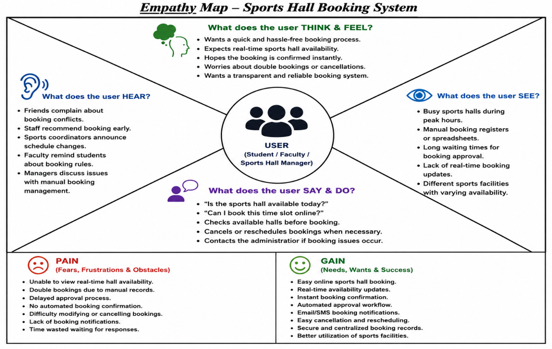

Example: Food Ordering & Delivery Application
